**Reflection Document**

**Name**: Ahmed Mashaal  
**Course**: IS601  
**Project**: Final Project

Throughout this course, I have gained valuable experience in designing, implementing, and testing software systems. This epic project allowed me to combine various skills learned in the course, including API development, automated testing, Docker deployment, and effective collaboration using GitHub.

Key learnings include:

1. The importance of **test-driven development (TDD)**: Writing tests for each feature improved my confidence in the code and reduced bugs significantly.
2. Leveraging **FastAPI and SQLAlchemy**: I deepened my understanding of Python frameworks and how to build scalable, asynchronous web applications.
3. **Collaborative development**: Managing GitHub issues, creating branches, and closing issues fostered a structured approach to project management.
4. **Deployment to DockerHub**: Packaging and deploying the project as a Docker image streamlined the process of sharing and running the application.
5. **Importance of 12 Factor App Methodology**: I learned about the 12 factor app methodology and how everything is standardized noe.

This project demonstrated the significance of clean coding practices, extensive testing, and documentation. Below, I provide links to specific components of my project.

**Closed GitHub Issues**

I resolved **5 QA issues** during this project. The links to these issues are as follows:

1. #5: Fixed the curl of Toggle to include all fields without any nulls in the response.
2. #4: Upgrade to Toggle: Change from upgrading the user to ability to move back and forth between making the account professional and not.
3. #3: Vulnerability issues with docker: fixed the version of software required to prevent any vulnerabilities.
4. #2: Admin Create User Authentication Email Issue: Email was not authenticating when admin creates account
5. #1: Create_User Response has linkedin showing as null in response

**New Tests**

I created **10 new tests** for this project, focusing on edge cases and ensuring comprehensive coverage.

Links to Test Code

* **Test_users_api.py**
  + [Line - 196]: [Upgrade to Professional - Success](https://github.com/mashal99/user_management/blob/main/tests/test_api/test_users_api.py)
  + [Line - 209]: [Upgrade to Professional - User Not Found](https://github.com/mashal99/user_management/blob/main/tests/test_api/test_users_api.py)
  + [Line - 222]: [Upgrade to Professional - Unauthorized Access](https://github.com/mashal99/user_management/blob/main/tests/test_api/test_users_api.py)
  + [Line - 231]: [Upgrade to Professional - Access Denied](https://github.com/mashal99/user_management/blob/main/tests/test_api/test_users_api.py)
* **Test_user_model.py**
  + [Line - 144]: [Set Professional Status - True](https://github.com/mashal99/user_management/blob/main/tests/test_models/test_user_model.py)
  + [Line - 163]: [Set Professional Status - False](https://github.com/mashal99/user_management/blob/main/tests/test_models/test_user_model.py)
* **Test_upgrade_to_professional.py**
  + [Line - 167]: [Toggle Professional Status - Success](https://github.com/mashal99/user_management/blob/main/tests/test_services/test_user_service.py)
  + [Line - 181]: [Toggle Professional Status - Multiple Toggles](https://github.com/mashal99/user_management/blob/main/tests/test_services/test_user_service.py)
  + [Line - 200]: [Toggle Professional Status - Non-Existent User](https://github.com/mashal99/user_management/blob/main/tests/test_services/test_user_service.py)
  + [Line - 209]: [Toggle Professional Status - Already Professional](https://github.com/mashal99/user_management/blob/main/tests/test_services/test_user_service.py)

**Feature Implementation**

The feature I implemented was **"Upgrade to Toggle"**, which allows users to toggle their professional status. This feature includes:

* A new API endpoint [/users/{user_id}/upgrade-professional.](https://github.com/mashal99/user_management/blob/main/app/routers/user_routes.py)
* Updates to the user model to handle toggling status.
* Full testing for both the service and endpoint.

**DockerHub Deployment**

The project is successfully deployed to DockerHub. You can find the repository here:  
DockerHub Repository Link: <https://hub.docker.com/repository/docker/amashaal99/user_manager/general>

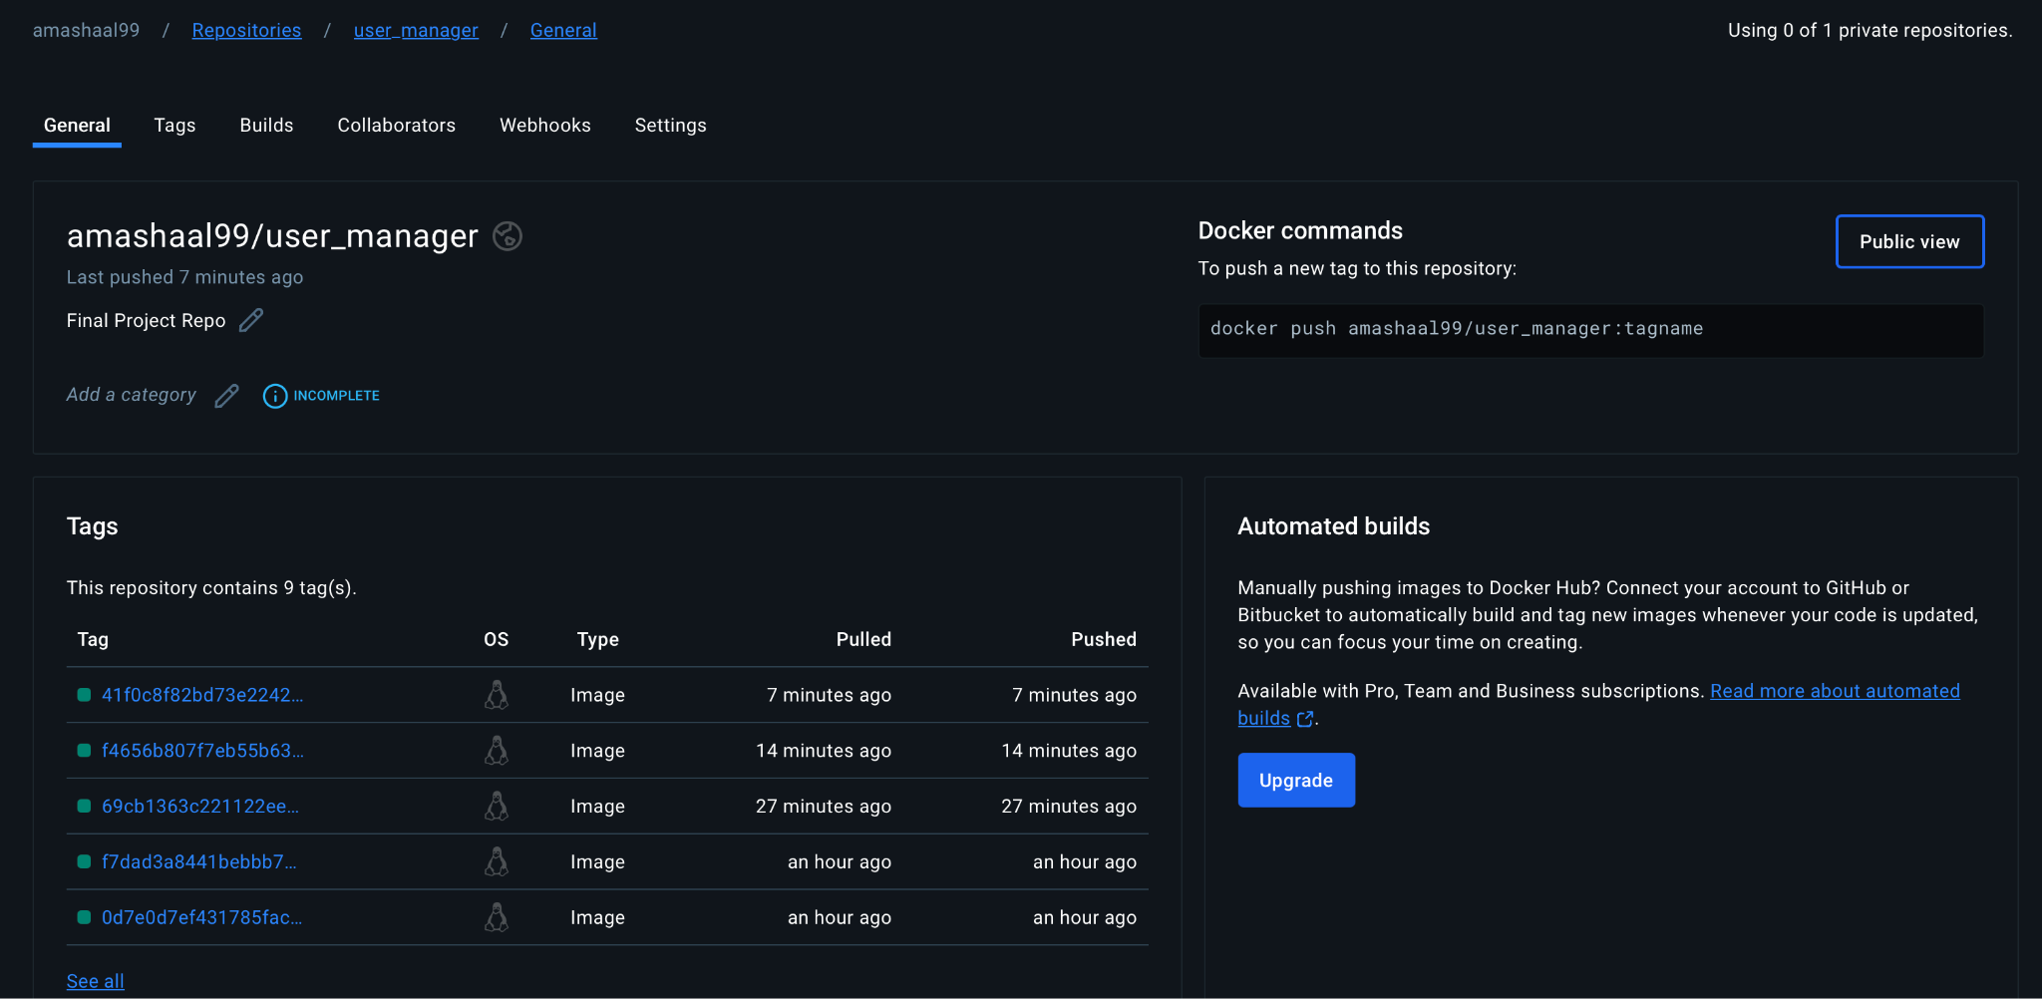

This project was a valuable experience that combined technical skills, project management, and collaborative development. It prepared me for real-world software engineering challenges and highlighted the importance of testing and deployment in the development lifecycle.